**Rami Wail Shoula: Collections**

1. **Collections Selected**
2. **HashSet<T>**
3. **List<T>**
4. **SortedDictionary<TKey, TValue>**

**All technical information was gathered from Microsoft documentation at**

**Ref:** [**https://docs.microsoft.com/en-us/dotnet/api/system.collections?view=net-6.0**](https://docs.microsoft.com/en-us/dotnet/api/system.collections?view=net-6.0)

1. **Visual Studio (Practical Data)**

**As instructed in the Lec. To get any collection data from within Visual Studio the procedure is:**

**View -> Object Browser -> Search //or shortcut Ctrrl + Alt + J**

1. **HashSet<T>**

**public class HashSet<T>**

**Member of System.Collections.Generic**

**Summary:**

**Represents a set of values.**

**Type Parameters:**

**T: The type of elements in the hash set.**

1. **List<T>**

**public class List<T>**

**Member of System.Collections.Generic**

**Summary:**

**Represents a strongly typed list of objects that can be accessed by index. Provides methods to search, sort, and manipulate lists.**

**Type Parameters:**

**T: The type of elements in the list.**

1. **SortedDictionary<TKey, TValue>**

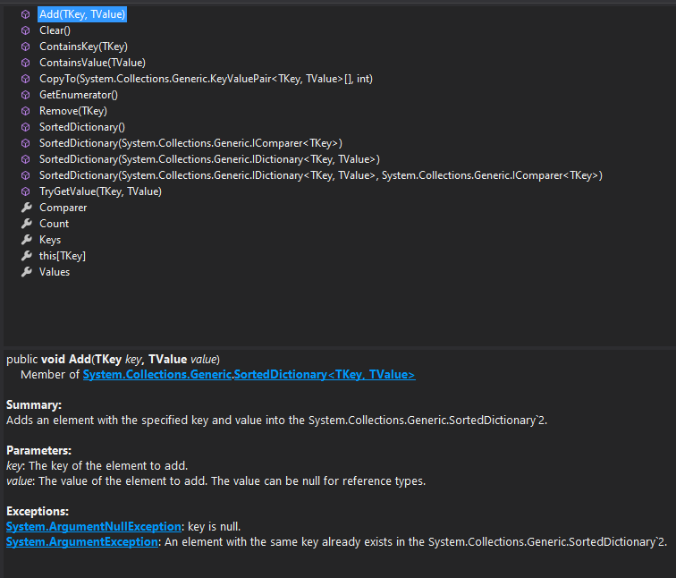

**public class SortedDictionary<TKey, TValue>**

**Member of System.Collections.Generic**

**Summary:**

**Represents a collection of key/value pairs that are sorted on the key.**

**Type Parameters:**

**TKey: The type of the keys in the dictionary.**

**TValue: The type of the values in the dictionary.**

1. **Technical Information: HashSet<T>**

**Ref:** [**https://docs.microsoft.com/en-us/dotnet/api/system.collections.generic.hashset-1?view=net-6.0**](https://docs.microsoft.com/en-us/dotnet/api/system.collections.generic.hashset-1?view=net-6.0)

1. **Definition**

1. **Type Parameters**

1. **Examples**

1. **Remarks**

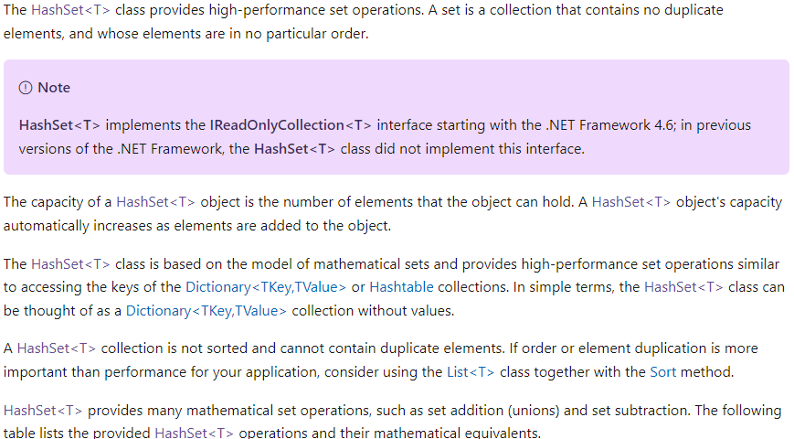

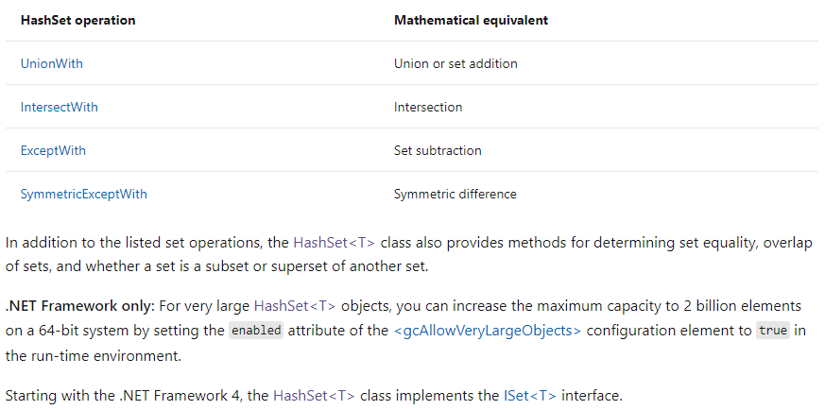

1. **Technical Information: List<T>**

**Ref:** [**https://docs.microsoft.com/en-us/dotnet/api/system.collections.generic.list-1?view=net-6.0**](https://docs.microsoft.com/en-us/dotnet/api/system.collections.generic.list-1?view=net-6.0)

1. **Definition**

1. **Type Parameters**

1. **Examples**



**Output:**

1. ID: 1234 Name: crank arm
2. ID: 1334 Name: chain ring
3. ID: 1434 Name: regular seat
4. ID: 1444 Name: banana seat
5. ID: 1534 Name: cassette
6. ID: 1634 Name: shift lever
7. Contains("1734"): False
8. Insert(2, "1834")
9. ID: 1234 Name: crank arm
10. ID: 1334 Name: chain ring
11. ID: 1834 Name: brake lever
12. ID: 1434 Name: regular seat
13. ID: 1444 Name: banana seat
14. ID: 1534 Name: cassette
15. ID: 1634 Name: shift lever
16. Parts[3]: ID: 1434 Name: regular seat
17. Remove("1534")
18. ID: 1234 Name: crank arm
19. ID: 1334 Name: chain ring
20. ID: 1834 Name: brake lever
21. ID: 1434 Name: regular seat
22. ID: 1444 Name: banana seat
23. ID: 1634 Name: shift lever
24. RemoveAt(3)
25. ID: 1234 Name: crank arm
26. ID: 1334 Name: chain ring
27. ID: 1834 Name: brake lever
28. ID: 1444 Name: banana seat
29. ID: 1634 Name: shift lever
30. **Remarks**

1. **Technical Information: SortedDictionary<TKey, TValue>**

**Ref:** [**https://docs.microsoft.com/en-us/dotnet/api/system.collections.generic.sorteddictionary-2?view=net-6.0**](https://docs.microsoft.com/en-us/dotnet/api/system.collections.generic.sorteddictionary-2?view=net-6.0)

1. **Definition**

1. **Type Parameters**

1. **Examples**

1. **Remarks**

